**1302. Deepest Leaves Sum**

Medium

119656Add to ListShare

Given the root of a binary tree, return *the sum of values of its deepest leaves*.

**Example 1:**

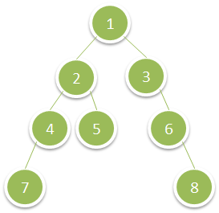

**Input:** root = [1,2,3,4,5,null,6,7,null,null,null,null,8]

**Output:** 15

**Example 2:**

**Input:** root = [6,7,8,2,7,1,3,9,null,1,4,null,null,null,5]

**Output:** 19

**Constraints:**

* The number of nodes in the tree is in the range [1, 104].
* 1 <= Node.val <= 100

Accepted

93,769

Submissions

110,235